**Project Report**

**Project Title**

**Exploratory Data Analysis for Oil and Gas fields**

**Team Leader:**

G.Sandhya Rani 21R11A0569

**Team Members:**

Shivanoor Vignesh 21R11A0597

PSBN Sriya 21R11A0595

N.Sai Charan 21R11A0588

MD.Akhbar Ali 21R11A0586

**Histogram for Shale Footage**

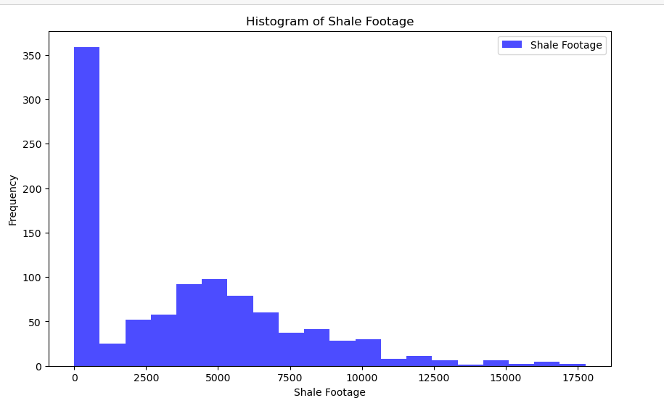

**Observation-**

1.Most of the shale footage values are concentrated on the left side (smaller values), while fewer occurrences are observed as the shale footage increases.

2.The high frequency of smaller shale deposits (0 to 2500) suggests that these are common.

3.Operators likely encounter numerous wells with relatively low shale footage.

**Count of Treatment Company-**

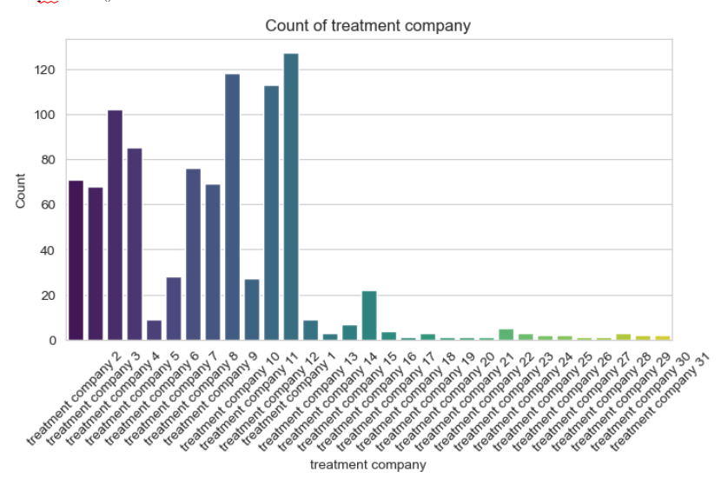

**Observation-**

As we can observe from the above count plot that treatment company 1 has more count than other companies. Hence we can say that it provides more treatment services than other companies.

**Count of Operator**-

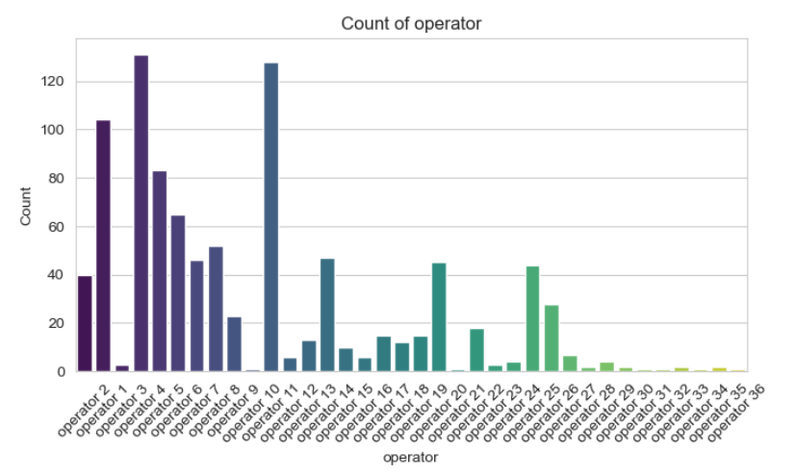

**Operation-**

1.The above count plot reveals that Operator 4 demonstrates the highest frequency in the count, implying a notable prevalence in providing drilling services among the operators. This observation suggests that Operator 4 has been extensively involved in the execution of drilling operations, potentially indicating a significant contribution to the overall drilling services.

**Comparison between Shale Footage and Production-**

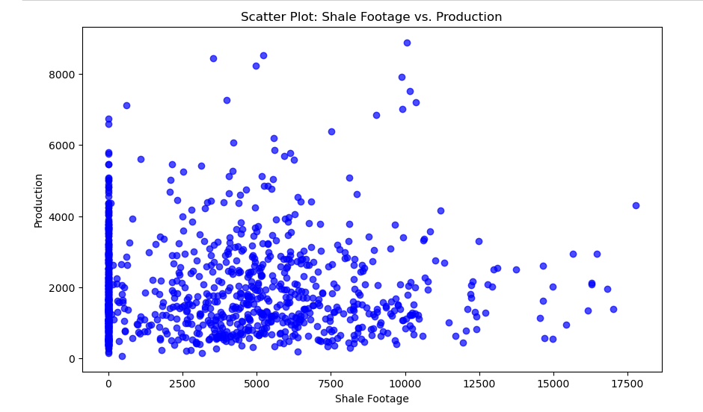

**Observation-**

1. There is a dense cluster of data points at the lower end of the shale footage axis (around 0 to 2500).This suggests that many wells with relatively small shale footage are still productive

2.As shale footage increases beyond approximately 2500, the data points become more scattered.

3. Some wells exhibit high production even with large shale footage, while others have lower production.

**Comparison between Footage lateral length and Production-**

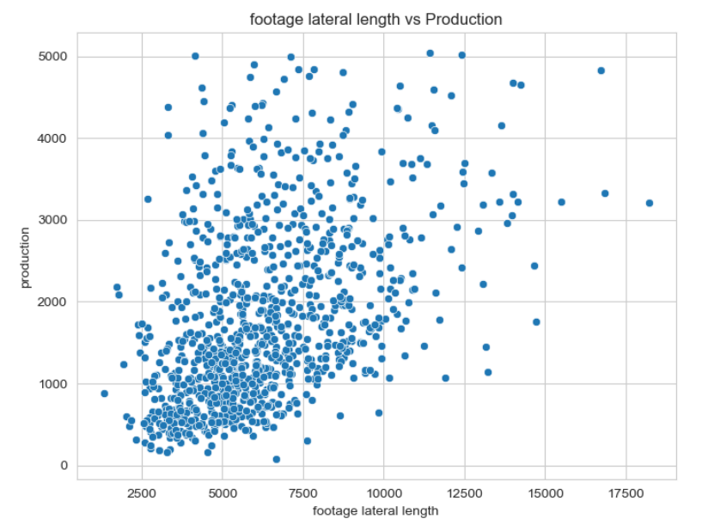

**Observation-**

1.The scatter plot reveals a clustered distribution of data points. Most of the data points are concentrated in the lower-middle section of the graph.

2.As the footage lateral length increases, the data points become more dispersed. Fewer data points are observed at higher values of both axes. This implies that higher lateral lengths do not always guarantee proportionally higher production.

3.There seems to be an optimal range for lateral length where production is most efficient. Operators should aim for lateral lengths within this range to maximize output.

**Correlation between Log Permeability and Production-**

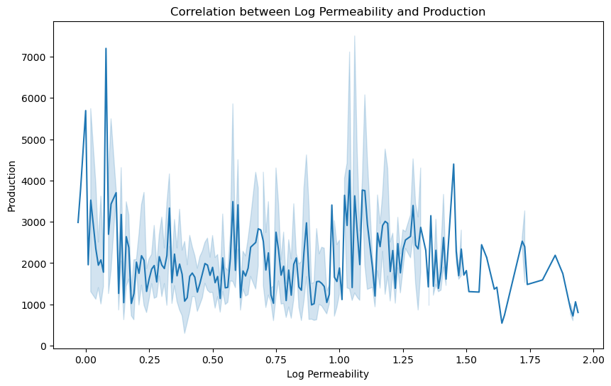

**Observation-**

1. From the graph depicting the correlation between Log Permeability and Production ,we can say that the relationship between log permeability and production is non-linear .Unlike a straightforward positive or negative correlation, production values fluctuate widely across different log permeability levels.

2.Sharp peaks in production occur at various points along the log permeability axis. These peaks represent specific conditions where production is exceptionally high.

3.The troughs (low points) are more varied:

- Some are broad, indicating a range of log permeability values with reduced production.

-Others are narrow, suggesting specific log permeability levels associated with lower production.

**Correlation between Porosity and Production:**

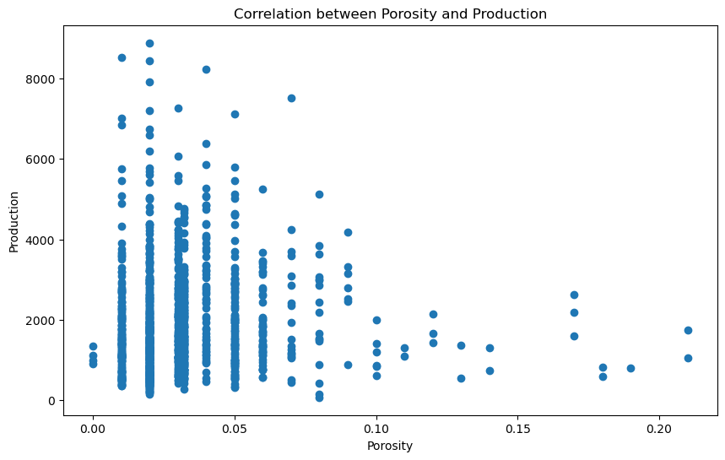

**Observation-**

The above graph reveals that there is a negative correlation between porosity and production. At the lower percentage values of porosity ,the production is seemed to be high and as the percentage values increases the production decreases.

**Correlation between Pump rate and Production-**

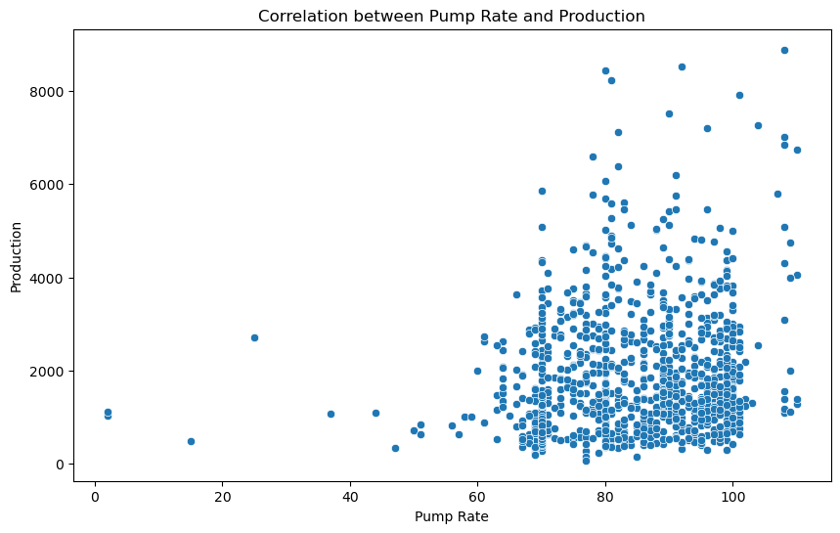

**Observation-**

The above graph depicts that there is a positive correlation between pump rate and production . As the Pump rate increases ,the production increased.

**Correlation between Acoustic Impedance and Production-**

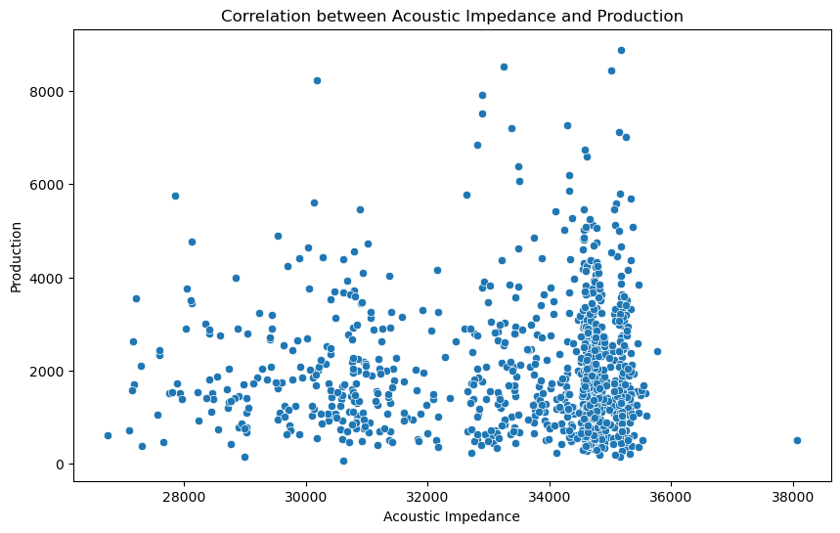

**Observation-**

1.The scatter plot shows a positive correlation between acoustic impedance and production.

2.As acoustic impedance increases, particularly beyond a certain threshold (around 34,000 units), there is a significant increase in production levels.

3.This implies that higher acoustic impedance is associated with more efficient production.

Beyond this range, further increases in impedance may not yield proportional gains in production.

**Relation between Total Organic Carbon and Production-**

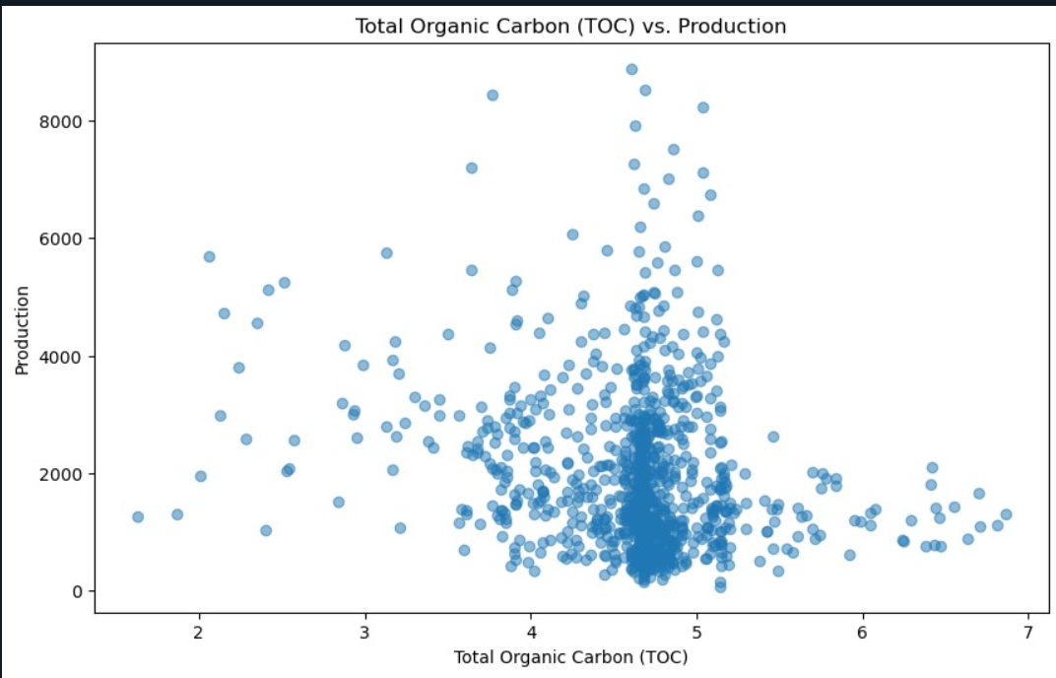

**Observation-**

1. The presented graph illustrates the correlation between Total Organic Carbon (TOC) and Production. Notably, it reveals that there is a peak in production when the hydrocarbon generative potential falls within the range of 4-5.
2. In this specific range, there is an observed increase in production, suggesting a positive relationship between Total Organic Carbon levels and hydrocarbon yield.

**Relation between VCL(Amount of clay minerals) and TOC(Total Organic Carbon)-**

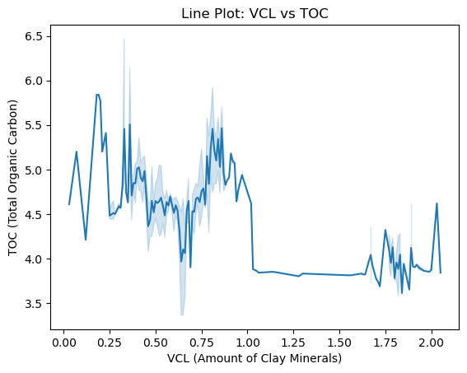

**Observation-**

1.The depicted graph delineates the association between the quantity of clay minerals and Total Organic Carbon (TOC). Notably, the TOC reaches its peak around 5.9 when the amount of clay minerals is approximately 0.25. Subsequently, despite fluctuations, the TOC consistently remains below 5.9.

2.In the range of 1.00 to 1.6, there is almost constant values are observed in the TOC.

**Relation between Production and Well spacing-**

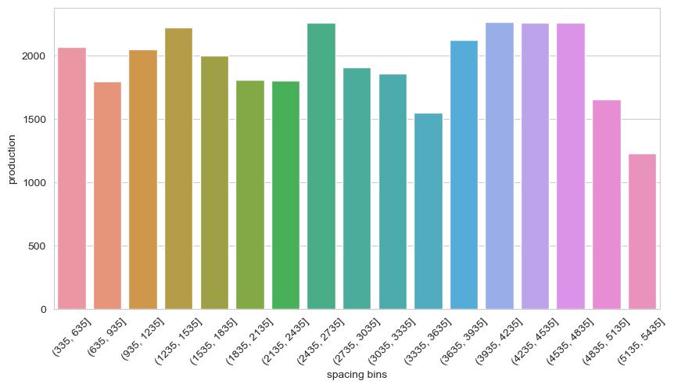

**Observation-**

1. The above graph depicts the relation between well spacing and production.From the above graph we can say that around 3935-4835 range the production is constant and relatively high and later on production decreased as the range increases.
2. Operators should mainly focus on this range for efficient production.

**Average production across the years(2011-2019)-**

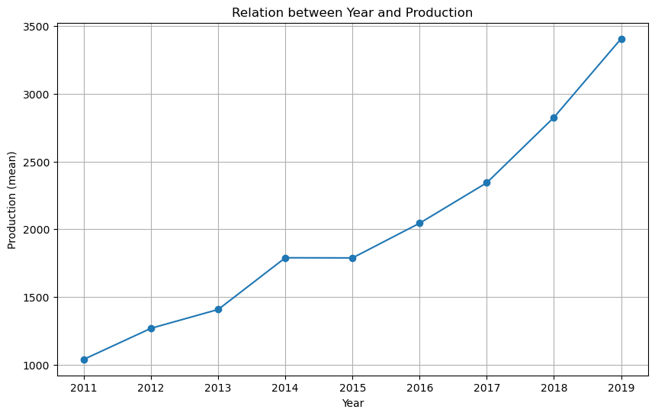

**Observation-**

1. The above graph shows the average production across years(2011-2019).
2. As we can see from 2011 to 2019 the production increased and in between 2014 -2015 the production is constant.

**Average production across months in an year-**

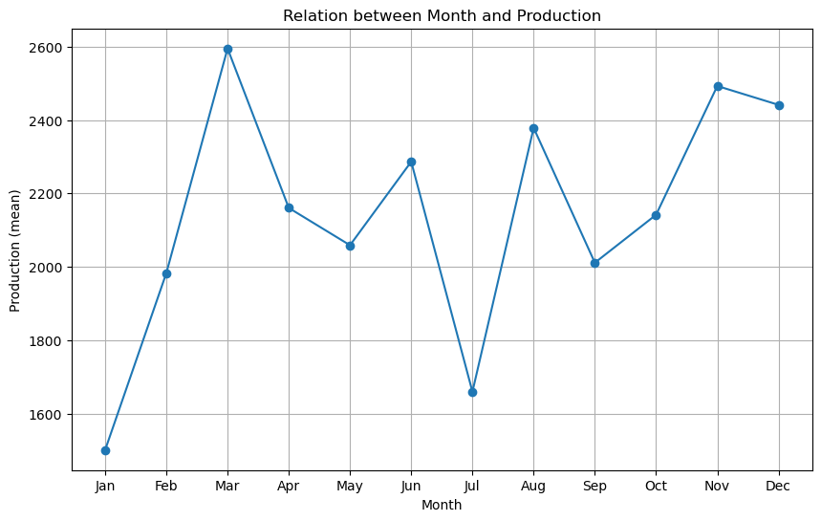

**Observation-**

1. The above graph shows the average production across 12 months(Jan-Dec).
2. As we can see that there is a continuous increase in the production from January to march with highest production in march.
3. And the January produced low production compared to all the months.